Quick Lin File Editing in aaBridge
Written by Roger Pfister roger@RogerPf.com http://RogerPf.com/aaBridge
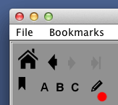
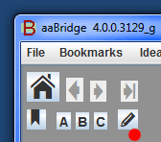
aaBridge has a "Quick Edit" feature for lin files.
It is the pencil icon, showing on the right in Windows and Mac.

Once set up, you can click the pencil icon and if the current Tutorial Lin file you are in is editable it will open in the editor.
If you are not in a Tutorial Lin file but are inside a deal AND you have Saved that deal, using the Save or Save As buttons (top right in the green area) – THEN – instead that lin file will open in the editor.
Set up – you are running Windows
1. Install NotePad++ https://notepad-plus-plus.org/ (in the std place on C:) and you are done. (Sorry but aaBridge will not find any other Win editor)
2. Set you computer to show the 'extensions' at the end of filenames. See
http://windows.microsoft.com/en-us/windows/show-hide-file-name-extensions

Set Up – you are running Mac OSX
1. Install the Text editor. BBEdit (The trial version is fine – you do NOT need the pay for features) or any other good TEXT File editor will do fine. http://www.barebones.com/products/bbedit/download.html

2. Set you computer to show the 'extensions' at the end of filenames. See
https://support.apple.com/kb/PH19072?locale=en_US
Mac - Set Up continued on NEXT page

Set Up – you are running Mac OSX (continued)
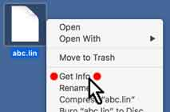
On a Mac (and on Linux) you have to tell the system that .lin files need to be opened with the Editor of your choice (here BBEdit).
3. Select ANY existing .lin file right click to get the menu and do Get Info
OR
(if right-click is hard for you) select the lin file and click File on the top bar and Get Info is there.
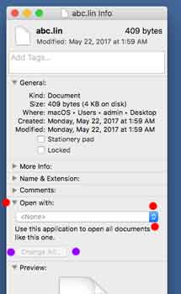
You can see the Get Info
dialog on the right.
4. Click Open With
(single red dot)
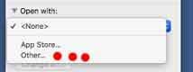
5. Click <none> or the drop
down arrows (two dots)
6. Click Other ... (3 dots)
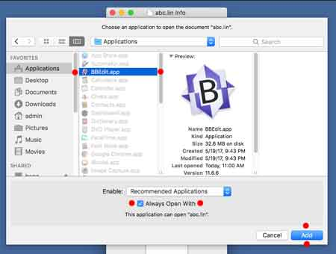
7. Below - the dialog will open
a) Select your editor - BBEdit (red dots)
b) Check - Always Open With
c) Click - Add
8. Back on the image above.
The Change All button
will now be active. (purple dots)
Click it and
accept the confirmation.
and you are done.
<end document>

